**Power BI Capstone Project Report**

**SHOPNEST STORE ANALYSIS**

**Task 1: Top Categories by Total Price**

**Question Statement:**

Identify and visually represent the top 10 product categories by total sales.

**Visualization:**

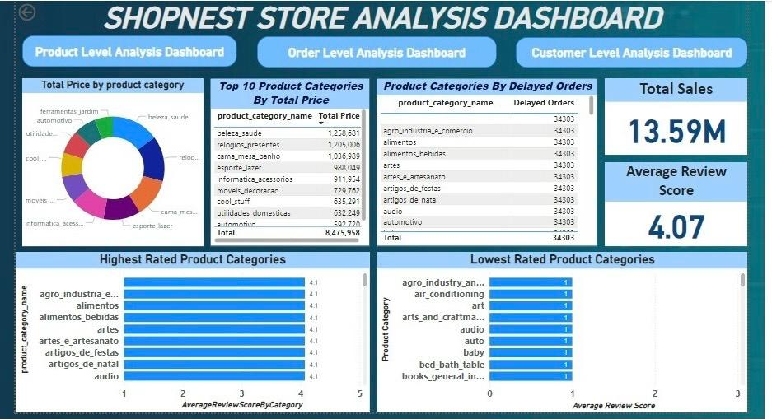

**Explanation:**

The 1st table displays the top 10 product categories based on total sales. The `Total Sales` measure was calculated by summing the `Price` column from the `Order_items` dataset. The table is sorted in descending order to highlight the highest-grossing categories.

**Key Insights:**

- Top Category: The category `beleza_saude` leads with the highest total sales, amounting to 1,258,681.

- Significant Categories: Other significant categories include `relogios_presentes` (1,205,006), `cama_mesa_banho` (1,036,989), and `esporte_lazer` (988,049).

- Sales Distribution: The top 10 categories contribute significantly to the overall sales, indicating a focus on these categories can drive revenue.

**Task 2: Delayed Orders Analysis**

**Question Statement:**

Determine the number of delayed orders in each category. An order is considered delayed if the actual delivery date is later than the estimated delivery date.

**Visualization:**



**Explanation:**

The 2nd table above shows the number of delayed orders in each product category. A delayed order is defined as one where the actual delivery date is later than the estimated delivery date. The `Delayed Orders` measure was calculated by comparing the `Order_delivered_customer_date` and `Order_estimated_delivery_date` columns from the `Orders` dataset.

**Key Insights:**

- Consistent Delays: All categories have an equal number of delayed orders.

- Data Uniformity: The uniformity in the number of delayed orders across all categories suggests there might be a data consistency issue or a systemic problem affecting all categories equally.

**Task 3: Monthly Comparison of Delayed and On-Time Orders**

**Question Statement:**

Create a dynamic visual that compares the number of delayed orders to the number of orders received on time for each month. Utilize the drill-through cross-report feature to provide a detailed analysis of late and on-time deliveries.

**Visualization:**

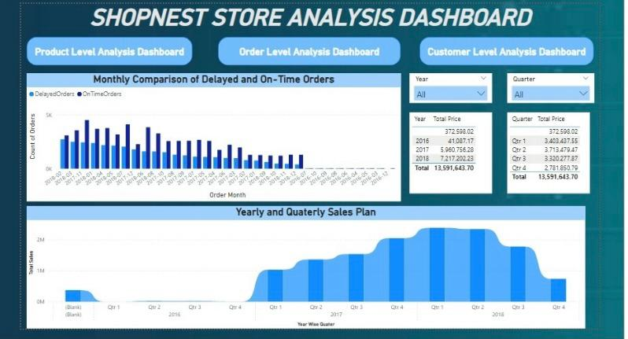

**Explanation:**

The clustered column chart above compares the number of delayed orders to the number of on-time orders for each month. The `OrderMonth` column from the `Orders` dataset is used to group the data by month. The number of delayed orders is calculated by counting the orders where the actual delivery date is later than the estimated delivery date, while the number of on-time orders is calculated by counting the orders where the actual delivery date is on or before the estimated delivery date.

**Key Insights:**

- Trend Analysis: The chart shows the monthly trend of delayed and on-time orders from September 2016 to October 2018. The volume of both delayed and on-time orders fluctuates over the period.

- High Delay Periods: Significant spikes in delayed orders are observed in November 2017 and March 2018. These periods indicate potential issues in the supply chain or logistics that caused a high number of delays.

- Improvement in Delivery: There is a noticeable improvement in on-time deliveries from late 2017 to mid-2018, with the number of on-time orders consistently higher than the number of delayed orders.

**Task 4: Payment Method Analysis**

**Question Statement:**

Analyse the most frequently used payment methods by customers using a visually appealing representation, such as a pie chart or other suitable visuals.

**Visualization:**

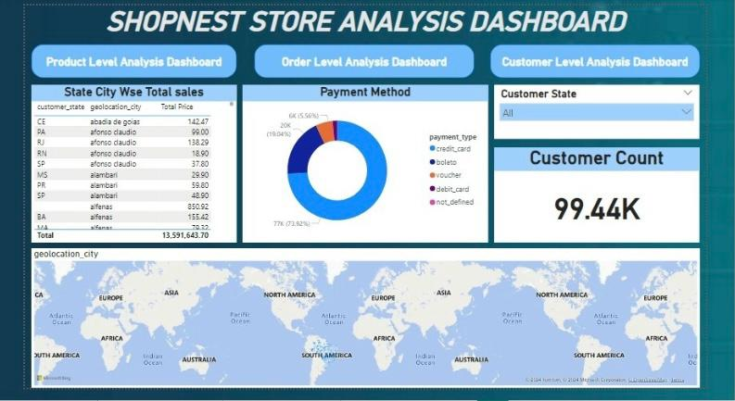

**Explanation:**

The pie chart above represents the distribution of different payment methods used by customers. The `payment_type` column from the `Order_payments` dataset is used to categorize the payment methods. The number of transactions for each payment method is counted to determine the frequency of usage.

**Key Insights:**

- Dominant Payment Method: The “credit_card” is the most frequently used payment method, with 77k transactions, accounting for the majority of the payment preferences.

- Other Significant Methods: “boleto” (a popular payment method in Brazil) follows with 20K transactions, and `voucher` is used 6K times.

- Less Common Methods: “debit_card” is relatively less common.

**Task 5: Product Rating Analysis**

**Question Statement:**

Determine the top 10 highest-rated product categories and the bottom 10 lowest-rated product categories based on their average review scores.

**Visualization:**



**Explanation:**

This bar chart visualizes the average review scores for various product categories. Each bar represents a product category, and the length of the bar corresponds to the average review score for that category.

- Top 10 Highest-Rated Product Categories:

- These categories have the longest bars, indicating they have the highest average review scores.

- Categories such as “agro-industria”, “alimentos”, alimentos_bebidas”, “artes”, etc are among the highest-rated.

- Bottom 10 Lowest-Rated Product Categories:

- These categories have the shortest bars, indicating they have the lowest average review scores.

- Categories such as “air-conditioner”, art and craftman, audio etc are among the lowest-rated.

**Key Insights:**

- Top-Rated Categories: Categories such as “agro-industria”, “alimentos”, alimentos_bebidas”, “artes”, etc are among the highest-rated suggesting they are well-received by customers.

- Lowest-Rated Categories such as “air-conditioner”, art and craftman, audio etc are among the lowest-rated, indicating potential areas for improvement or customer dissatisfaction.

**Task 6: State-wise Sales Analysis**

**Question Statement:**

Identify and visually represent states with high and low sales, providing a clear understanding of regional sales performance.

**Visualization:**



**Explanation:**

This table displays the total sales for different states in Brazil. Each bar represents a state, and its length corresponds to the total sales amount in that state. The chart is divided into two sections: states with high sales and states with low sales.

**Key Insights:**

- States with High Sales: São Paulo (SP), Rio de Janeiro (RJ), Minas Gerais (MG), and Paraná (PR) emerge as the top states with the highest sales figures.

- States with Low Sales: Roraima (RR), Acre (AC), Tocantins (TO), and Amapá (AP) are among the states with lower sales figures.

This effectively highlights the regional inconsistency in sales performance across different states, providing insights that can guide strategic decisions related to marketing efforts, distribution channels, and customer engagement strategies.

**Task 7: Seasonal Sales Patterns**

**Question Statement:**

What are the seasonal sales patterns on a quarterly basis?

**Visualization:**

Below is a bar chart that visualizes the total sales amount for each quarter:



**Explanation:**

The graph provides a clear view of the seasonal sales patterns over the course of the year, segmented into quarters:

1. Qtr 1 (January to March): This quarter shows a gradual increase in sales, peaking in March. The sales trend suggests a strong start to the year.

2. Qtr 2 (April to June): Sales continue to rise into the second quarter, with April and May showing consistent high sales figures. June slightly dips compared to May but remains strong overall.

3. Qtr 3 (July to September): There is a significant spike in sales during July, likely due to summer vacations and seasonal promotions. August maintains high sales, while September shows a slight decline from August but remains robust.

4. Qtr 4 (October to December): This quarter starts strong in October and November, with October particularly showing a peak in sales. December, although lower compared to October and November, remains higher than earlier quarters, likely due to holiday shopping.

**Key Insights:**

- Seasonal Variation: The data clearly exhibits seasonal variation, with higher sales during specific quarters reflecting consumer behaviour influenced by seasonal factors like holidays and weather conditions.

- Quarterly Trends: Each quarter has its own distinct sales pattern, influenced by external factors and consumer spending habits of that time of year.

**Task 8: Revenue Analysis:**

**Question Statement:**

Determine the total revenue generated by ShopNest Store and analyze how it changes over time (Yearly).

**Visualization:**



**Explanation:**

The visualization depicts the total revenue generated by ShopNest Store from 2016 to 2018. Each year's revenue is represented in a table with the corresponding total revenue amount displayed.

- Yearly Revenue Trends:

- In 2016, the total revenue was $41,087.17.

- The revenue significantly increased in 2017, reaching $5,960,756.28.

- There was a further increase in 2018, with the revenue amounting to $7,217,202.23.

**Key Insights:**

- Year-on-Year Growth: The revenue shows a clear upward trend over the years, indicating the store's growth and increasing sales.

- Significant Growth in 2017: There was a substantial increase in revenue from 2016 to 2017, suggesting successful business expansion or improved market conditions.

- Steady Growth in 2018: The revenue continued to grow in 2018, albeit at a slightly slower rate compared to the previous year.

Conclusion:

- The steady growth in revenue indicates that ShopNest Store has been successful in increasing its sales over the years.

Analyzing other factors such as Product Diversification, Product Lifecycle, target market, customer behaviour, customer lifetime value or promotional benefits could provide deep insights into the revenue growth patterns.

This visual representation underscores the fluctuations and trends in ShopNest Store's revenue over the specified years, offering critical insights to inform strategic decisions and shape future planning.